Regulatory Affairs Professionals Society – Website Development
Case Study

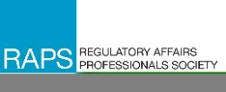
About the Regulatory Affairs Professionals Society
The Regulatory Affairs Professionals Society (RAPS) is the largest global organization for those involved in the regulation of healthcare and related products, which include medical devices, pharmaceuticals, biologics, and nutrition products. RAPS helped establish the regulatory profession and continues to actively support the professional and lead the profession as a neutral, non-lobbying nonprofit organization.
Pumex helped rescue RAPS from a previous vendor’s that was not delivering on quality or promises. Our work with RAPS highlights our attention to on-time product delivery within budget and minimizing risks through project management.

Executive Summary
Pumex was tasked with taking on a highly visible web development project for RAPS on the Kentico CMS platform. The project touched highly trafficked areas of their website, the Home Page, and their Regulatory News page. Due to previous vendor cost overruns and failure to meet project timelines, RAPS technology was under significant pressure to produce the desired results. Pumex was also able to help quickly mitigate a DDoS cyber-attack on their website which recently took place.
The Solution
Our experience in Agile Development and success in creating repeatable success processes with Project Management, Communication, Risk Management, and Delivery assisted us in delivering their enhanced website. We were also able to redesign the RAPS homepage and create an improved “Regulatory Focus” news page using the Kentico CMS. Both projects were delivered on time, within the allocated funding, and above quality expectations. When RAPS informed Pumex of the cyber-attack, our IT team was immediately available to start troubleshooting and worked to quickly mitigate the attack by the following morning with Imperva.
The Challenge
RAPS was facing challenges with the development and design of its public-facing website. Their previous web development provider was unable to deliver a quality website due to late product delivery, budget overruns, and delayed project management/communication of risk. This was particularly unsatisfactory since RAPS’ web presence acts as their primary form of communication with their members, dissemination of relevant and useful industry information, center for e-commerce, and portal to their LMS. RAPS was also faced with a sophisticated DDoS cyber-attack originating from a foreign entity. This attack involved multiple IP addresses, a friendly bot disguise, and complex countermeasures.

Immediate Results
Updated website – Using rich media content, Pumex enhanced the RAPS website using their preferred .NET CMS, Kentico, with an MS-SQL backend.

Data driven enhancements – Pumex leveraged data driven metrics based on information gathered about how RAPS site users navigated the website to make informed decisions about site enhancements which further drove user engagement.

Secure website – Pumex was able to resolve the RAPS website’s DDoS cyber-attack in less than 24hrs, restoring full security to the website within that time.

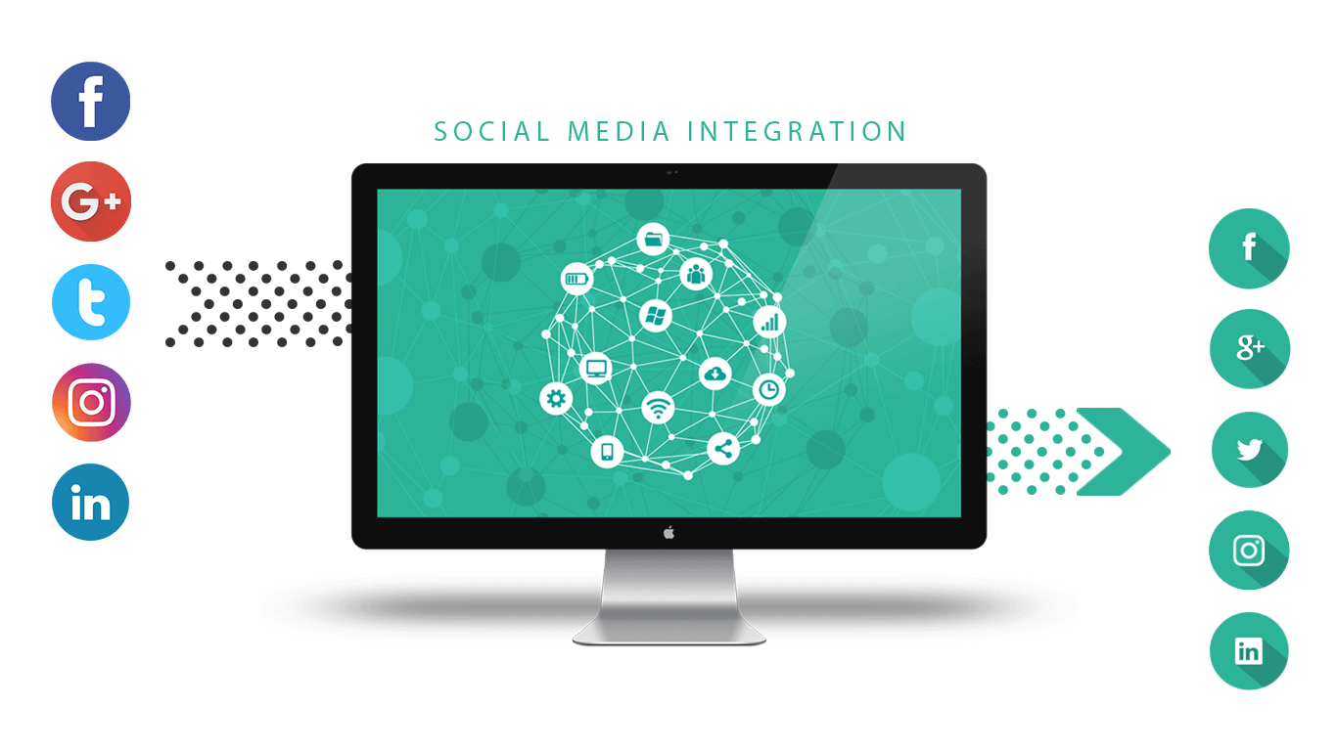

Future Plans
Pumex is RAPS vendor of choice for all web development, cloud infrastructure management, and cybersecurity requirements. Pumex is proud to continue supporting the highly complex RAPS website with many custom web parts and their ongoing infrastructure support needs.

